Accessing and using the the DSC Portal is Easy! Use these instructions to Log In, Create Your Personal Profile Sheet, and to Create your own Deal Sheets
- How to Log Into the DSC Portal
Step 1: Go to www.stylenet.com/dsc , you will see this box
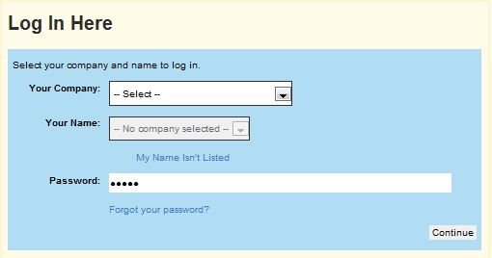
Step 2: Find your Company Name from the drop down menu, then find your name, finally enter your password. Your password is salon. You can change your password once inside the portal.
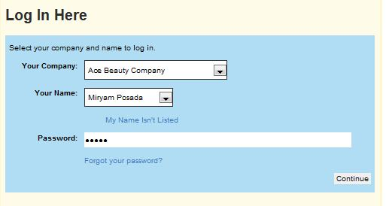

Step 3: Click Continue…You’re in! It’s that Easy!

- Once inside the DSC portal you can Create Your Personal Profile Sheet.
Step 1: Click on DSC Sales Tools
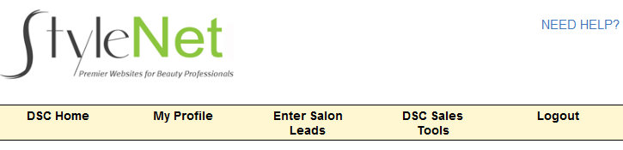
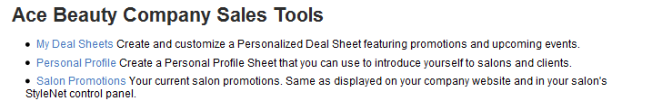
Step 2: Click on Personal Profile

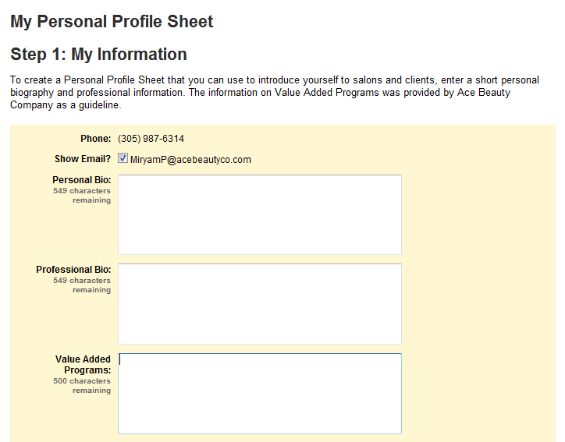
Step 4: You will be taken to this screen where you will enter your information. Say a little about yourself personally, your interests, activities, etc., then, say something about yourself Professionally. What you bring to the table. This is your resume for the salon. Make it GREAT! Additionally, there is a section to add Value Added Programs.

Step 5: Select up to 5 of your brands you would like displayed on your Personal Profile Sheet, then click Save
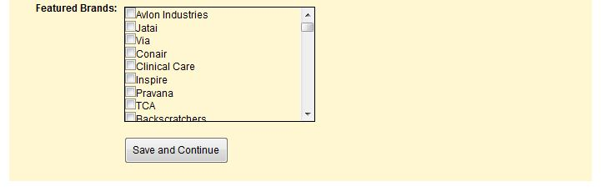
Step 5: When you press Save & Continue you now can pick a design template for your profile sheet. Click on the circle next to the design you wish to use, then click Publish
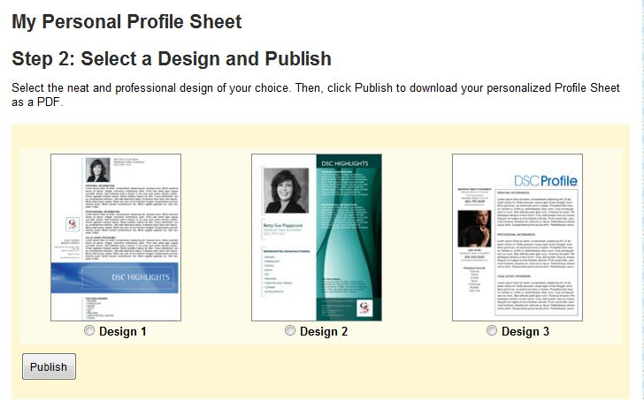

Click on the circle next to the design you wish to use

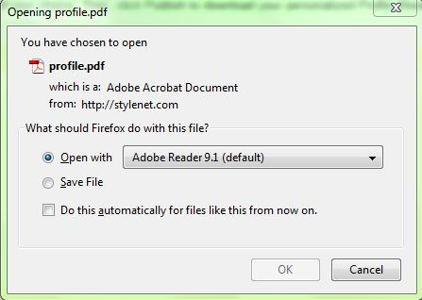
Step 6: Likely, you will see this Screen Pop Up. Select Open and then, OK. Presto! You have your Personal Profile Sheet!

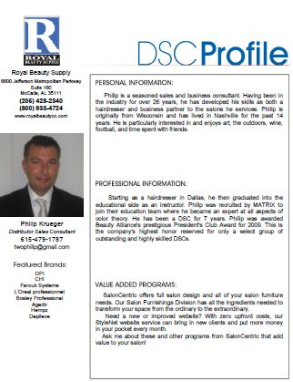
Here are a couple of Examples:

- Create a Deal Sheet
Step 1: Login to the DSC Portal (See previous instructions)
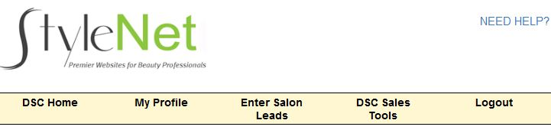
Step 2: Click on DSC Sales Tools

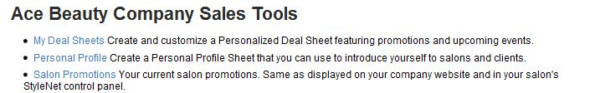
Step 3: Click on My Deal Sheets

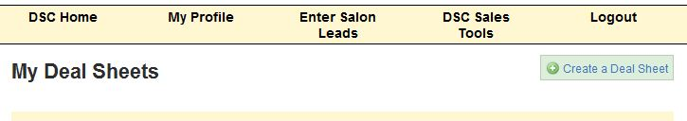
Step 4: Click on the Blue Box that says Create a Deal Sheet

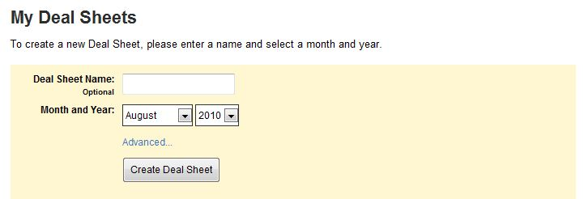
Step 5: You will see this box. You can name the Deal sheet if you like, or leave it blank. Select a Month and Year, then Click Advanced.

Step 6: You will see a list of your Monthly Promotions, something like this, select between 4-5 promotions you wish to have appear on your Deal Sheet
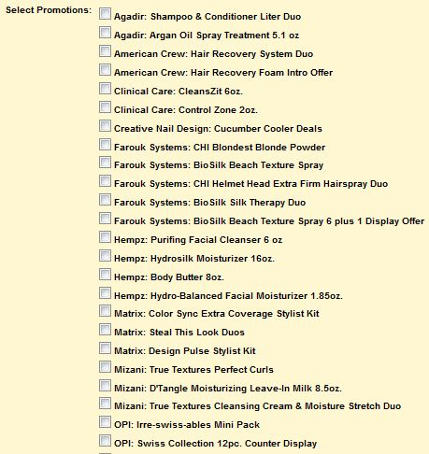
Step 7: After you have selected the 4-5 Promotions, Click on Create Deal Sheet

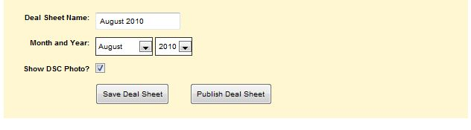
Step 8: You can choose to Save for later or publish (View & Print) the Deal sheet now

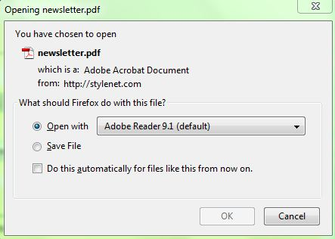
Step 9: If you choose to save the deal sheet, it will be saved and ready for you are to print later. If you choose to publish the deal sheet, you will see this box. Select Open and then OK.

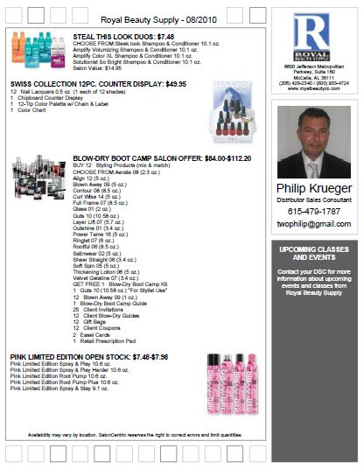
Then, Presto! You have something that looks like this!

